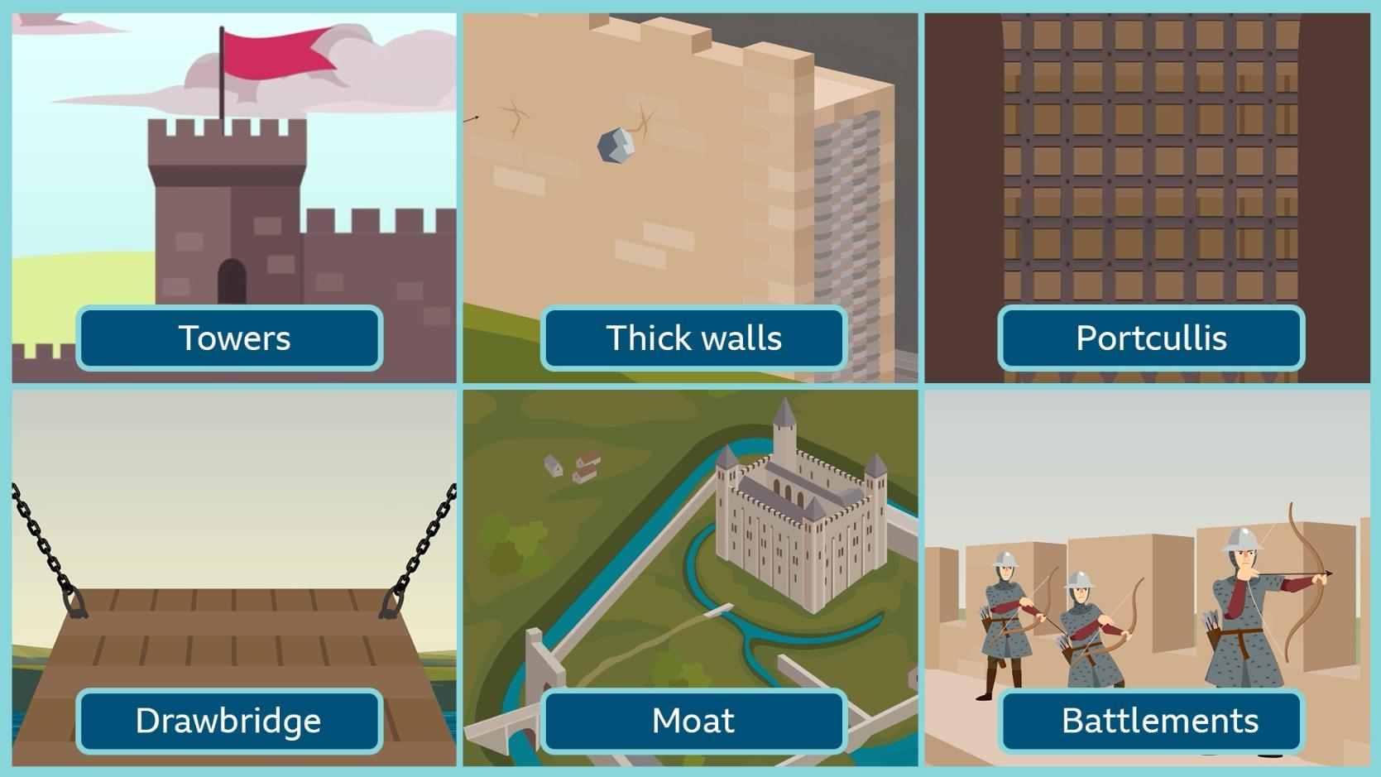
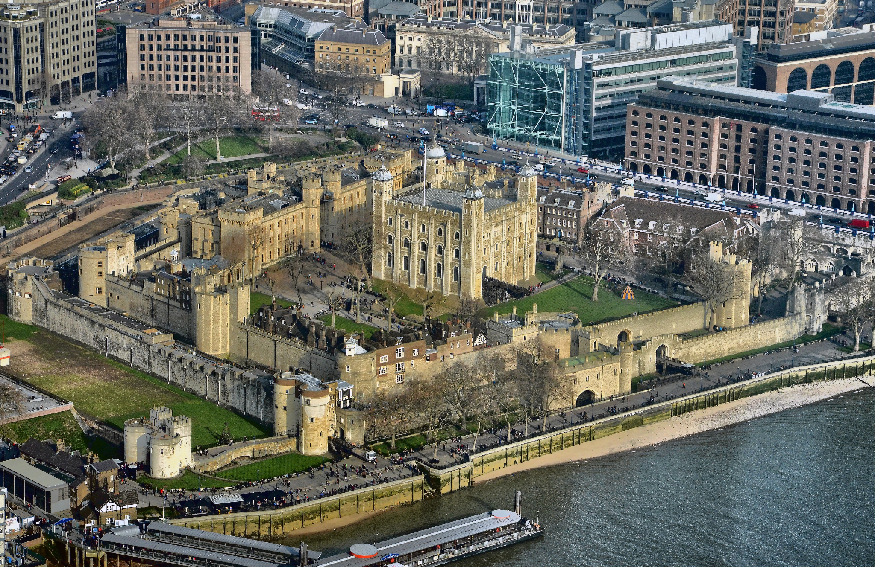
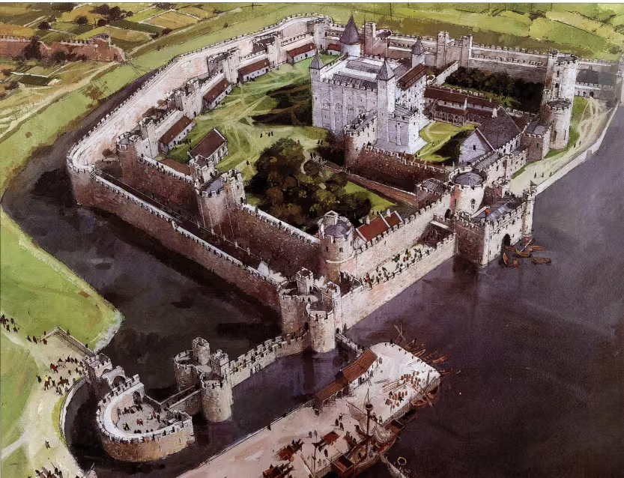
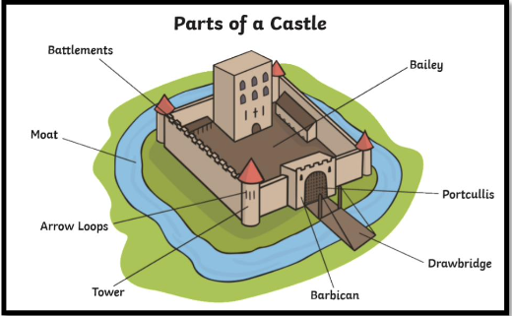
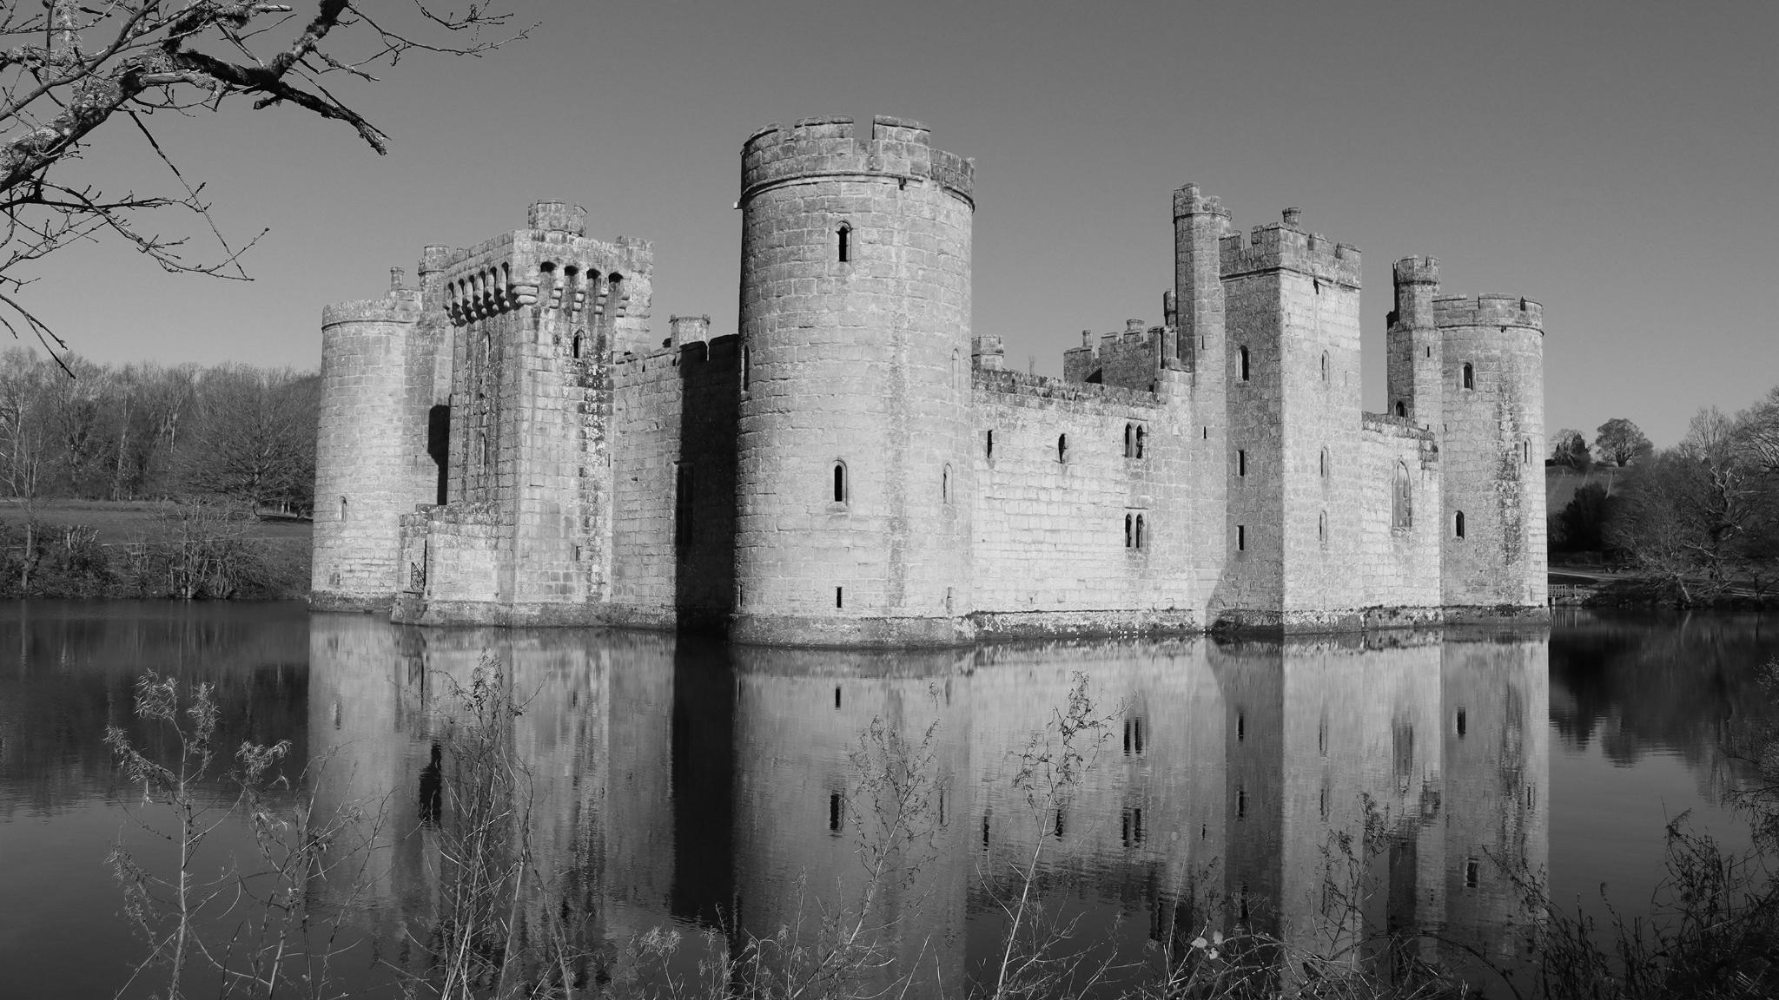
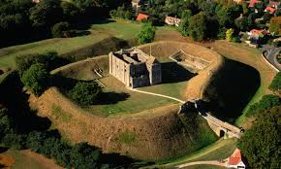
Mary Seacole
To understand who Mary Seacole was and the main events of her life
To create a timeline of Mary Seacole’s life
To explore how racism affects people now and in the past
To understand how Cholera was treated during the lifetime of Mary Seacole
To understand why Mary Seacole’s journey to Crimea was difficult
To know about the work of Mary Seacole and the impact it had
To remember and celebrate the achievements of Mary Seacole
Pupils will build on their knowledge of the substantive concepts: Country, Empire, Invasion

Stone Age to Iron Age
What is ‘prehistory’?
The Palaeolithic, Mesolithic and Neolithic periods. Changes, lifestyle and achievements. Bronze age - life and community. How do we know about the Iron age? Chronology of the period.
Remembrance
Black History Month
Pupils will build on their knowledge of the substantive concepts: Settlement, Society

Castles
Who built the first castles?
Who lived in Castles?
What are the features of a Castle?
Was the castle at Castle Rising an important castle?
How have the uses of Castle Rising changed over time?
Pupils will build on their knowledge of the substantive concepts: Country, Empire, Settlement, Monarchy, Invasion
The Tower of London Today
Vocabulary
Tapestry - A large piece of heavy cloth with a picture sewn into it.
Battlements - The top of the castle wall with raised and lowered sections.
Conquerors - A country or group of people that take complete control of another country or group’s land.
Defences - Keeping something strong in battle.
Motte - The mound of ground on which the castle is built.
Moat - A deep ditch around a castle
Keep - A fortified/strong tower built within the castle to help defend it.
Bailey - The outer wall.
Invade - To enter a country or place by force with an army.
Medieval - This refers to the ‘Middle Ages’
Knight- A noble man who served his king or lord in battle.
Taxes - Money that you have to pay to people who rule the country or land.
Revolt - An illegal and often violent attempt to take power.
The Tower of London in the Past
Castle Rising Castle
Prior Learning Future learning

