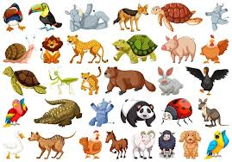
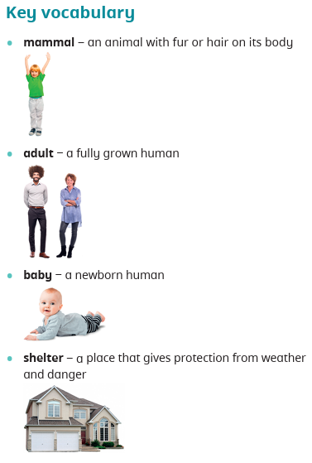
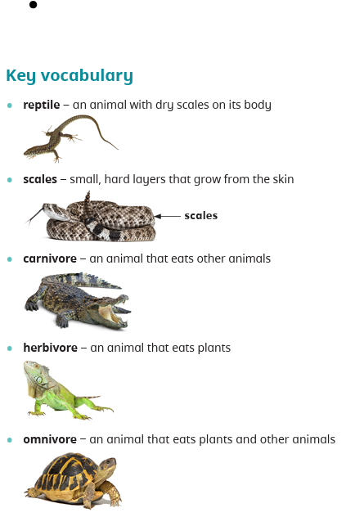

dentify and name a variety of common animals that are carnivores, herbivores and omnivores. (Y1 - Animals, including humans)
Identify, name, draw and label the basic parts of the human body and say which part of the body is associated with each sense. (Y1 - Animals, including humans)
Identify that animals, including humans, need the right types and amount of nutrition, and that they cannot make their own food; they get nutrition from what they eat. (Y3 - Animals, including humans)
Describe the differences in the life cycles of a mammal, an amphibian, an
insect and a bird. (Y5 - Living things and their habitats)
Describe the life process of reproduction in some plants and animals. (Y5 - Living things and their habitats)
Recognise the impact of diet, exercise, drugs and lifestyle on the way their bodies function. (Y6 - Animals, including humans)

Prior Learning Animals need for survival Future learning
Autumn Term
Find out about and describe the basic needs of animals, including humans, for survival (water, food and air).Working scientifically −
Asking simple questions and recognising that they can be answered in different ways.
Working scientifically – Gathering and recording data to help in answering questions.
Working scientifically − Identifying and classifying.
Working scientifically − Using their observations and ideas to suggest answers to questions.



