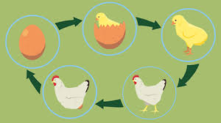
Identify and name a variety of common animals that are carnivores, herbivores and omnivores. (Y1 - Animals, including humans)
Identify, name, draw and label the basic parts of the human body and say which part of the body is associated with each sense. (Y1 - Animals, including humans)

Notice that animals, including humans, have offspring which grow into adults.
Working scientifically
Identifying and classifying.
Asking simple questions and recognising that they can be answered in different ways.
Record and communicate their findings in a range of ways and begin to use simple scientific language.

Identify that animals, including humans, need the right types and amount of nutrition, and that they cannot make their own food; they get nutrition from what they eat. (Y3 - Animals, including humans)
Describe the differences in the life cycles of a mammal, an amphibian, an
insect and a bird. (Y5 - Living things and their habitats)
Describe the life process of reproduction in some plants and animals. (Y5 - Living things and their habitats)
Recognise the impact of diet, exercise, drugs and lifestyle on the way their bodies function. (Y6 - Animals, including humans)

Prior Learning Growing up Future learning
Summer Term


