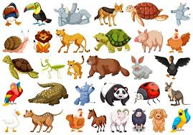
Identify and name a variety of common wild and garden plants, including deciduous and evergreen trees. (Y1 - Plants)
Identify and describe the basic structure of a variety of common flowering plants, including trees. (Y1 - Plants)
Identify and name a variety of common animals including fish, amphibians, reptiles, birds and mammals. (Y1 - Animals including humans)
Identify and name a variety of common animals that are carnivores, herbivores and omnivores. (Y1 - Animals including humans)
Describe and compare the structure of a variety of common animals (fish, amphibians, reptiles, birds and mammals, including pets). (Y1 – Animals, including humans)
Observe changes across the four seasons. (Y1 - Seasonal changes)

Explore and compare the differences between things that are living, dead, and things that have never been alive
Identify that most living things live in habitats to which they are suited and describe how different habitats provide for the basic needs of different kinds of animals and plants, and how they depend on each other.

Identify and name a variety of plants and animals in their habitats, including micro-habitats
Describe how animals obtain their food from plants and other animals, using the idea of a simple food chain, and identify and name different sources of food

Recognise that living things can be grouped in a variety of ways. (Y4 - Living things and their habitats)
Explore and use classification keys to help group, identify and name a variety of living things in their local and wider environment. (Y4 - Living things and their habitats)
Recognise that environments can change and that this can sometimes pose dangers to living things. (Y4 - Living things and their habitats) Construct and interpret a variety of food chains, identifying producers, predators and prey. (Y4 - Animals, including humans)
Prior Learning Living things and their habitats (Spring Term) Future learning
Spring Term


