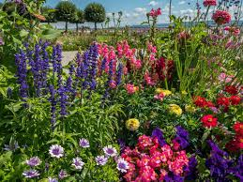
Identify and name a variety of common wild and garden plants, including deciduous and evergreen trees. (Y1 - Plants)
Identify and describe the basic structure of a variety of common flowering plants, including trees. (Y1 - Plants)
Identify and name a variety of common animals including fish, amphibians, reptiles, birds and mammals. (Y1 - Animals including humans)
Identify and name a variety of common animals that are carnivores, herbivores and omnivores. (Y1 - Animals including humans)
Describe and compare the structure of a variety of common animals (fish, amphibians, reptiles, birds and mammals, including pets). (Y1 – Animals, including humans)
Observe changes across the four seasons. (Y1 - Seasonal changes)

Find out and describe how plants need water, light and a suitable temperature to grow and stay healthy.
Working scientifically − Gathering and recording data to help in answering questions.
Working scientifically − Observing closely, using simple equipment

Recognise that living things can be grouped in a variety of ways. (Y4 - Living things and their habitats)
Explore and use classification keys to help group, identify and name a variety of living things in their local and wider environment. (Y4 - Living things and their habitats)
Recognise that environments can change and that this can sometimes pose dangers to living things. (Y4 - Living things and their habitats) Construct and interpret a variety of food chains, identifying producers, predators and prey. (Y4 - Animals, including humans)
Prior Learning Plants light and dark (Spring Term) Future learning
Spring Term


