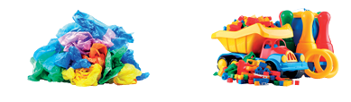
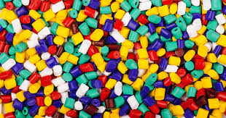
Caring for the planet (Y1)
Growing and Cooking (Y1)

Food Waste (Y3)
Biodiversity (Y3)
Energy (Y4)
Deforestation (Y4)
Global warming (Y5)
Plastic pollution (Y5)
Renewable Energy (Y6)
Light pollution (Y6)

Prior Learning Sustainability - Plastice Future learning
Autumn Term Year 2
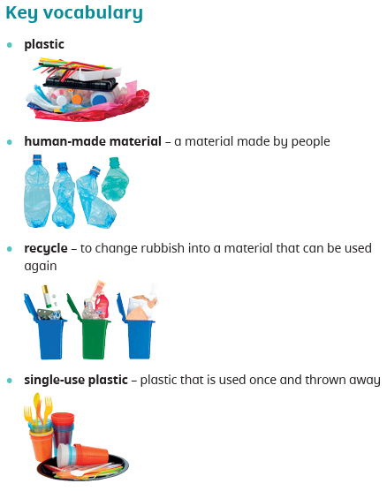
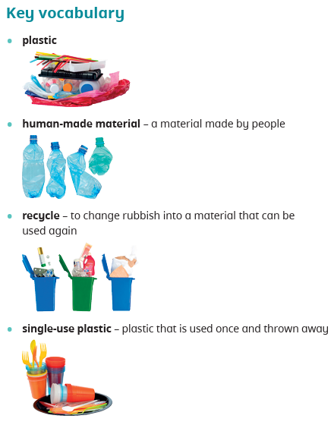
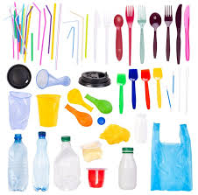
Working scientifically – Explore the world around them and raise their own questions (non-statutory).

How is plastic helpful and harmful?

Plastic can be helpful.
Plastic can be harmful to humans and other animals.
Some plastic can be recycled.
Some plastic cannot be recycled.

