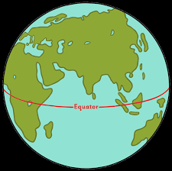
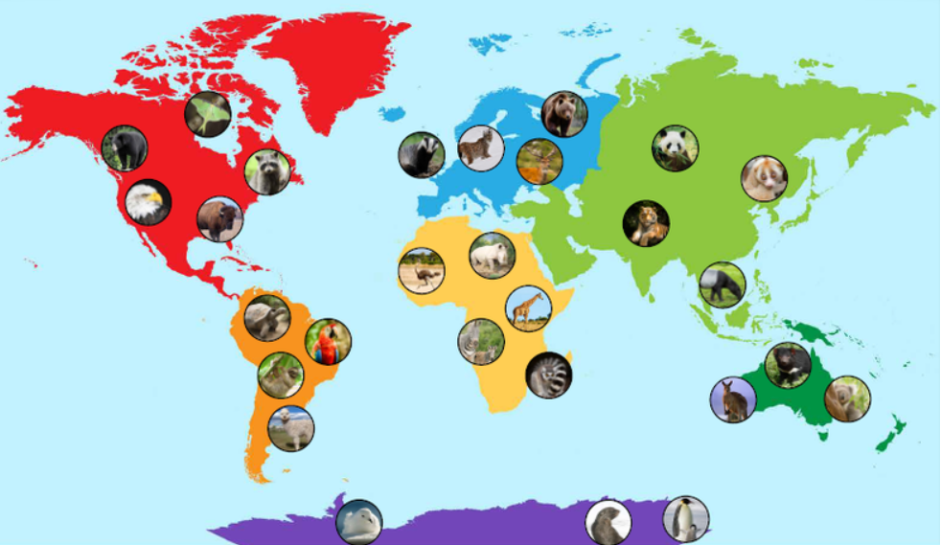
The Four Seasons: Winter, Spring, Summer, Autumn
The Seven Continents: North America, South America, Europe, Asia, Africa, Antarctica, Oceania
What animals can you see in our local area?
Vocabulary
Continent
Oceans
Seas
United Kingdom
Equator
Pole
Native
Seasons
Coastal
Marine

